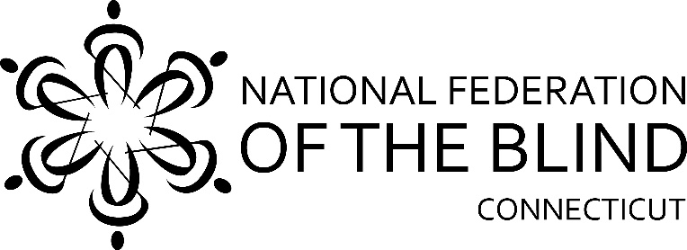

55th Annual State Convention!!
November 6th, 7th, and 8th
2026

The National Federation of the Blind of Connecticut will hold our 55th Annual State Convention on Friday, Saturday, and Sunday, November 6th, 7th, and 8th 2026 at the Hilton Garden Inn Hartford South/Glastonbury. Rooms will be available for Friday and Saturday nights for a convention discounted rate of $139.00 plus tax per night. To reserve a room, call Hilton Garden 860-659-1025 and use code 92E. The deadline for reserving a room for the convention is October 7, 2026.

On Friday there will be a social gathering from 7:00pm -10:00pm and a Vendor Fair from 7:00pm to 9:00pm. This will take place in rooms 2 and 3.

On Saturday morning, a full breakfast buffet will be served at 8:00am followed by our general session which starts promptly at 9:30am. We will hear from our National Representative and Affiliate President Maryanne Melley, and a variety of innovative speakers.

Lunch will be served from 12:30p.m.-1:30p.m. The Speakers will continue after lunch.
The CT Association of Guide Dog Users and Student Division will meet Saturday afternoon.

Our Banquet will begin at 6:00pm. All members must have a ticket to enter the room. There will be no exceptions. The National Representative will address our convention during the banquet Saturday evening. Presentation of Academic Scholarship Awards, basket and 50/50 drawings.
At the conclusion, please enjoy music and dancing.

On Sunday morning at 8:00am, a full breakfast buffet will be served before our 9:00am Annual Business Meeting. We will elect seven board members.

The National Federation of the Blind of Connecticut acknowledges.
With gratitude our convention sponsors are listed below:

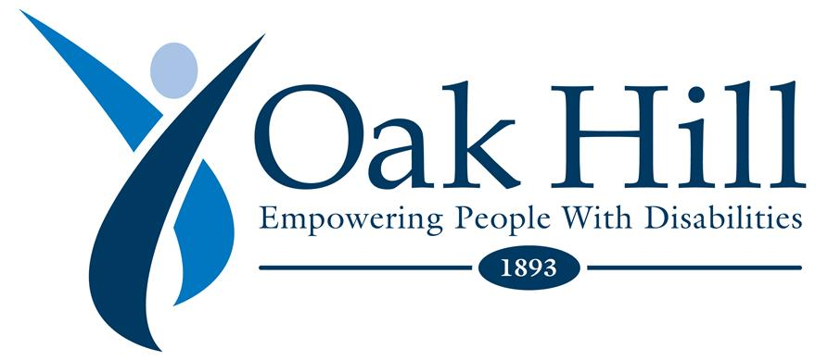

Vanda Pharmaceuticals
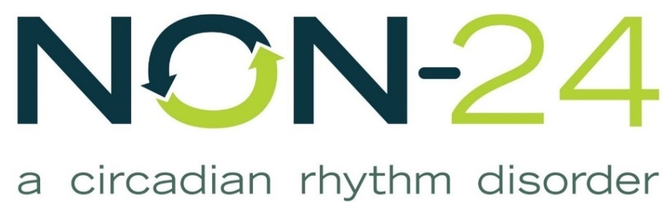
Non-24

Retina Consultants

The Cronin Family

Registration Form

Attendees who register at the door will pay an additional $10. Online registration will be available at www.nfbct.org under State Convention information.

Name:

Address:

Phone:

E-mail:

Please indicate the number attending each event:

Guide Dog Division ______________
Student Division_________________

_____ State Convention Registration Fee: $25 per person

Due to the inflated cost of the hotel this year, the CT Affiliate will be paying for everyone’s banquet dinner on Saturday. This is only for people staying overnight at the hotel. Please put your hotel confirmation # here _______.

Meals:
Saturday & Sunday breakfasts, Saturday lunch, and banquet dinner. This includes the registration fee and represents a $10 discount per person. $79.00 free Banquet. $109.00 paying for Eggplant. $113.00 paying for Chicken.

$22.00 Saturday Morning Breakfast Buffet, with eggs, bacon, sausage, etc. ____

$20.00 Saturday Lunch Choices: ____ Honey Roasted Turkey Sandwich, ____ Italian Sandwich, ________ Chicken Salad Sandwich ________ Grilled Vegetables Sandwich

Saturday Night Banquet Meal Choices: $34.00 ____ Chicken Francaise
$30.00 __ Eggplant Parnassian

$22.00 Sunday Morning Breakfast Buffet with eggs, bacon, sausage, etc. _____

Total payment (registration fee and meals): $

______ No, I cannot attend the 2026 state convention, but I am sending a donation to the NFB of CT.

Registration deadline is October 7th. Send your pay to the NFB of CT with your registration form to:
NFB of CT, 111 Sheldon Road, Unit 420, Manchester, CT 06045

