**53rd Annual State Convention!!**

**November 1, 2, and 3, 2024**

**The National Federation of the Blind of Connecticut will hold our 53rd Annual State Convention at the Courtyard by Marriott, Shelton. 780 Bridgeport Ave, Shelton CT 06484. Please call 203-929-1500 no later than October 11th to book your room. After that date you will not get the NFBCT rate of $129.00 + tax rate.**

On Friday night there will be two sessions, one in the main conference room given by Marci Carpenter, our National Representative, from 500pm-5:30pm. The other will be given by Linda Malendez, President of the New Jersey Affiliate for our sighted members in the Trumbull Room from 5:30pm-6:00pm. Dinner will be served in the main conference room at 6:30pm and a cash bar will be available. We will be holding our Vendor Fair on Friday evening from 7:00pm to 9:00pm in the hallway right outside the Main Conference Room where we will be gathered. Please remember to visit our Vendors!

On Saturday morning, a full breakfast buffet will be served at 8:00am followed by our general session which starts promptly at 9:00am. We will hear from our National Representative Marci Carpenter and the Affiliate President Maryanne Melley plus a variety of innovative speakers.

Lunch will be served from 12pm-1:00pm. Speakers will continue after lunch. The CT Association of Blind Students meeting will be held in the Fairfield Board room from 3:00pm-4:30pm. The CT Association of Guide Dog Users meetings will be held in the Trumbull Room from 3:00pm to 4:30pm.

Our Banquet will begin at 6:00pm. National Representative Marci Carpenter will address our convention during the banquet Saturday evening. Also, we will present the Academic Scholarship Awards.

We will, of course, have our 50/50 and basket raffles!

On Sunday morning at 8:00am, a full breakfast buffet will be served before our 9:00am Annual Business Meeting. We will elect seven positions.

**The National Federation of the Blind of Connecticut acknowledges**

**with gratitude our convention sponsors listed below:**

**Vanda Pharmaceuticals**

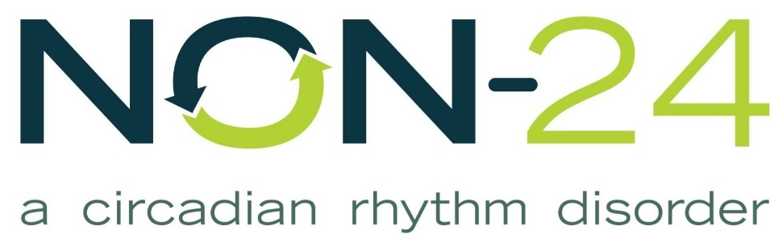

Non-24

**Oak Hill**

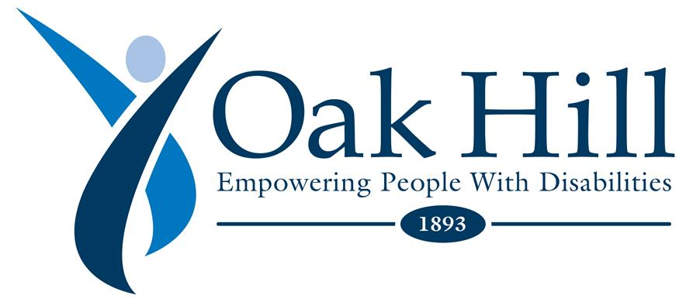

[Oak Hill](C:\\Users\\Lenovo\\AppData\\Local\\Microsoft\\Windows\\INetCache\\Content.Outlook\\JZ83YE81\\oakhillct.org)

**Achilles International**



Achilles Connecticut

**Jim Cronin**

**Registration Form**

Attendees who register at the door will be charged an additional $10. Please note that registrations can be made online at [www.nfbct.org](http://www.nfbct.org) following the link to State Convention information.

**Name**: ______________________________________________________

**Address**: _____________________________________________________

**Phone**: ______________________________________________________

**E-mail**: ______________________________________________________

**Indicate how many will be attending the following:**

**Division meetings Saturday Afternoon**

_____ CT Association of Guide Dog Users; _____ CT Association of Blind Students

_____ **State Convention Registration Fee: $20 per person**

**Meals:**

_____ Full convention package, $100 per person, which includes Saturday and

Sunday breakfasts, Saturday lunch and banquet dinner. This also includes the

registration fee and represents a $10 discount per person.

_____ Saturday Morning Full Breakfast Buffet, $18

_____Saturday Lunch Choices: ____Roast Beef Wrap, $18; ____Turkey Wrap,

$18; ___Ham Wrap $18; ____Garden Salad, $18

_____ Saturday Night Banquet Meal Choices: ____Stuffed Chicken, $40.

____Pasta Primavera, $40

______Sunday Morning Full Breakfast Buffet, $18

**Total payment (registration fee and meals): $______**

**______ No, I cannot attend the 2024 state convention, but I am sending a donation to the NFB of CT.**

**Registration deadline is October 18th.** Send your check payable to the NFB of CT with your registration form to or register online using PayPal on our website nfbct.org

**NFB of CT, 111 Sheldon Road, Unit 420, Manchester, CT 06045**