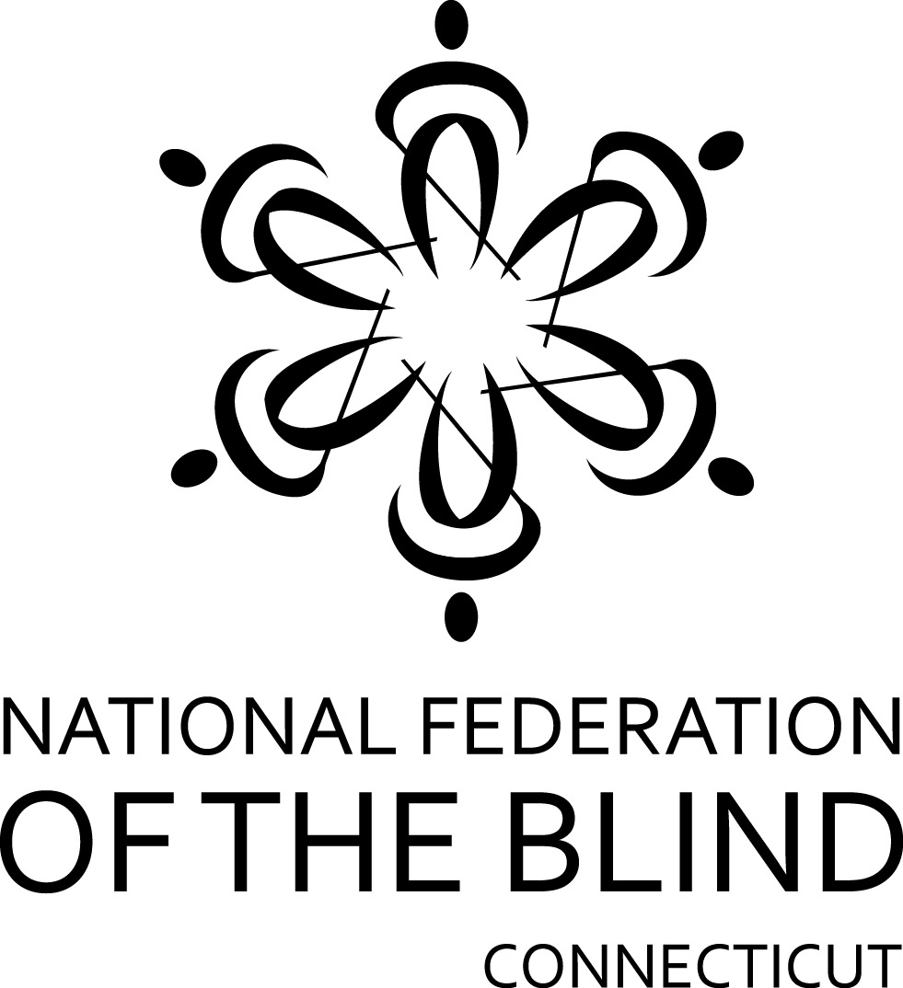
Brian Cummins
Memorial Scholarship
Sponsored by the
Brendan Cummins Family

The National Federation of the Blind of Connecticut is an organization of blind individuals who value the importance of a sound education along with proper reading and writing skills. In order to ensure the availability of certified teachers of the blind and visually impaired, the National Federation of the Blind of Connecticut is offering a scholarship in the amount of $2500. Recipients of this scholarship need not be a member of the National Federation of the Blind of Connecticut. Federation scholarships are judged on the basis of academic quality and service to the community.

Brian Cummins lost his life on September 11, 2001, in the World Trade Center tragedy. Brendan Cummins, whose son is blind, has asked that this scholarship be given in Brian’s memory.

Eligibility
Applicants must be a Connecticut resident or attending school in Connecticut and must be a college or graduate student enrolled in a full-time program to teach blind and visually impaired students in Connecticut.

Deadline – Notification
Completed applications must be submitted by September 1st. This scholarship will be presented at the banquet of the National Federation of the Blind of Connecticut State Convention. ANY FINALISTS ARE REQUIRED TO ATTEND OUR STATE CONVENTION ON THE FIRST WEEKEND OF NOVEMBER.

Please Complete Application Form on Reverse Side.
APPLICATION FORM

Applicant’s Name__________________________________________
Permanent Address________________________________________
__________________________Telephone______________________
Current Address (if different from above) ______________________
_________________________ Telephone______________________
E-Mail address: ___________________________________________
Currently enrolled full-time:
College/University Name & City_______________________________
Current Year of Study: ______Junior______Senior
Graduate Student: Year______
List Institutions Previously Attended (High School and/or College): ________________________________________________________
________________________________________________________
________________________________________________________

Attach the following documents:
- Applicant’s Letter: Describe your career goals and how our scholarship might help you in achieving them. Give us a brief biographical sketch – tell us about your academic interests, your extracurricular activities, awards/honors you may have received and any community service you have been involved in.
- Two Letters of Recommendation: From teachers, professors, employers, or other professionals who know you well.
- Official academic transcripts from all colleges/universities attended.

Applicant’s Signature__________________________Date_________

Mail your completed application and/or address any questions to:

National Federation of the Blind of Connecticut
111 Sheldon Road, Unit 420
Manchester, CT 06045
(860) 289-1971
www.nfbct.org

