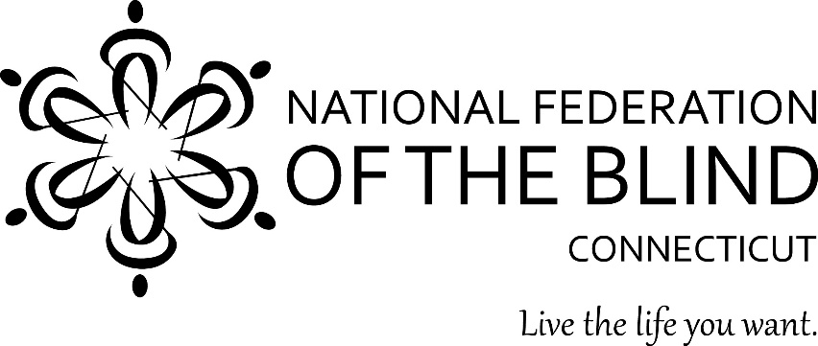

The National Federation of the Blind of Connecticut (NFB of CT) will host our 51st Annual State Convention on November 4th, 5th, and 6th 2022. The NFB is the largest membership organization of blind people in the United States. Our convention will be held in person at the Sheraton Hartford South, 100 Capitol Boulevard, Rocky Hill, CT 06067.

Our 2022 NFB of CT State Convention offers promotional opportunities for organizations that want to show support for the blind. Sponsorship of our convention provides an ideal way to give your company exposer to hundreds of attendees. Attached is information about sponsorship opportunities for our 2022 Annual State Convention.

For more information about this event, please contact the National Federation of the Blind of Connecticut outreach coordinator Lucia Lee at 860-289-1971 or info@nfbct.org, or contact our affiliate president, Maryanne Melley at 860-212-5549 or maryanne.melley@gmail.com

National Federation of the Blind of Connecticut
111 Sheldon Road, Unit 420, Manchester, CT 06045
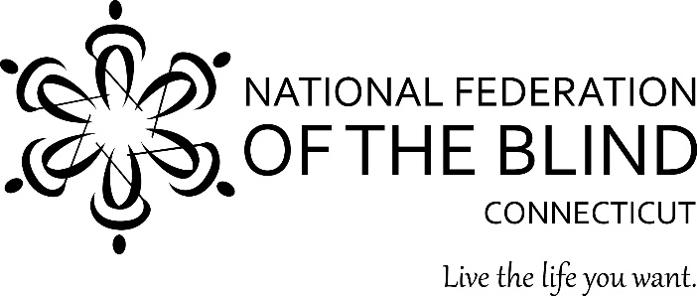

Annual State Convention Sponsorship Opportunities
November 4th, 5th, and 6th 2022

Becoming a sponsor of NFB of CT’s 2022 51st State Convention will show your commitment to assisting the blind in our state. You will find this a great opportunity to learn about the capabilities of blind people in leading productive lives, both professionally and in their community.

Platinum Sponsorship Level: $1000
- Your company name and logo will appear on any convention-related materials.
- Complimentary state convention registration.
- Link for sponsor’s website on our state convention webpage and on all emails
- Special recognition at our Saturday evening banquet.
- Social media recognition
- Opportunity to speak to our convention on Saturday morning.

Gold Sponsorship Level: $500
- Your company name and logo will appear on any convention-related materials.
- Complimentary state convention registration.
- Link to sponsor’s website on our state convention webpages and on all emails
- Special recognition at our Saturday evening banquet.
- Social media recognition

Silver Sponsorship: $250
- Your company name will appear on any convention-related materials.
- Complimentary state convention registration.
- Special recognition at our Saturday evening banquet.
- Social media recognition
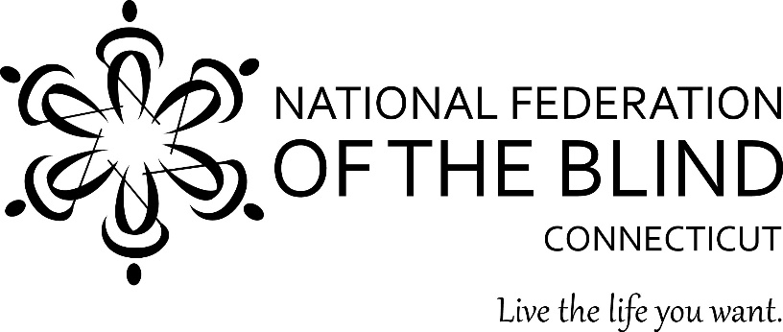

Sponsorship Registration Form
51st Annual State Convention
November 4th, 5th, and 6th 2022

Excellent exposure for your business!

Becoming a sponsor of NFB of CT’s 2022 51st State Convention will show your commitment to assisting the blind in our state. You will find this a great opportunity to learn about the capabilities of blind people in leading productive lives, both professionally and in their community.

We would like to sponsor the 2021 NFBCT State Convention:
  - X Platinum Sponsor $1000
  - Gold Sponsor $500
  - Silver Sponsor $250

Complete a Sponsor Registration Form by September 15, 2022, for your complimentary convention registration and sponsorship recognition in our press releases, brochures, emails, and agenda.

National Federation of the Blind of Connecticut
111 Sheldon Road, Unit 420, Manchester, CT 06045

